APPLICATION FORM FOR THE USE OF THE “KRSKOLESOM” BIKE RENTAL SYSTEM SERVICES WITH STATEMENT

I, the undersigned, declare that I wish to use the service of the KRsKOLESOM bicycle rental system.

STATEMENT

I declare that I agree with the General Terms and Conditions of Access and Use of the Bicycle Rental System. In the future, I will regularly consult the website https://www.gorenjska.bike where amendments and changes to the conditions and instructions will be published. I am also familiar with the instructions for the use of ordinary and electric bicycles.

The Tourism and Culture Board Kranj creates a user account in the KRsKOLESOM system for people who spend at least one night in an accommodation facility in the Municipality of Kranj. At this promotional registration, the user will show an identity document at their accommodation establishment. In order to operate the KRsKOLESOM system, the system manager, Tourism and Culture Board, will have to process personal data provided upon registration and strictly necessary for the operation and use of the system. For the purpose of using this system at the accommodation facility, the Institute for Tourism and Culture Kranj therefore requires the following user information:
NAME
SURNAME
PERMANENT/TEMPORARY ADDRESS
SEX | M F
TYPE OF IDENTITY DOCUMENT (circle) | passport identity card
I DENTITY DOCUMENT NUMBER
YEAR OF BIRTH
STREET AND HOUSE NUMBER
POST CODE AND CITY
COUNTRY
PHONE NUMBER
E-MAIL ADDRESS
DATE OF FIRST BIKE RENTAL IN KRANJ

I expressly agree that the system manager can charge me for the costs of repairing eventual damage to the bike or the system occurred during my use, as I am responsible for the rented bicycle for the duration of the bike rental. I am also aware that I use the bike rental system at my own risk and solely for my own purposes.
I declare that all the personal information stated above is true, accurate and complete, for which I have material and criminal liability.
I declare that I am available every day at the e-mail address and telephone number provided.

Date: ____________

Signature: ___________________

INSTRUCTIONS FOR USE

RENTAL OF A BICYCLE

- Select the bike you wish to rent and make sure that it is flawless.
- Access the computer terminal (kiosk) with the LCD display and tap in the display to start. Choose the appropriate language and follow the instructions. In order to use the system, enter your username and password.
- Follow the on-screen instructions to rent bicycles or other services.
- If you wish to rent a bike, wait for the system to check all the locks and inform you which bikes are available. It will offer you the lock numbers available to you.
- After you’ve selected one of the bicycles, please wait for the system to process your selection and confirm it. We recommend that you first check that all the bicycles are in good condition before choosing one of them.
- After confirmation, you have 20 seconds to access the lock with the selected bicycle and unlock it by pressing the silver button which will flash green.
- Then, after you have pressed the button, hold the seat with one hand and the handlebars with the other and first push the bicycle gently forward and then pull it back to remove it from the lock.
- In case you are unable to remove the bike from the lock for any reason, firmly push the bike back into the lock and make sure it is locked, then repeat the procedure from the start.
- After you have successfully rented and ridden the bicycle, simply push it back into the lock, this time a little bit harder, to lock it. Before leaving, always make sure that the bicycle is really locked. If it was successfully locked, the button on the lock will light up blue.
- If the button on the lock is red, this is a warning that you have not locked the bicycle correctly, so you have to repeat the process.
- Should all locks be occupied upon your arrival or should there be no bikes to rent at the station, please wait until the arrival of the maintenance service or look for the next station.
- In case of system failure, please call +386 (0) 1 530 5303 or, in case of registration problems, +386 (0) 4 23 80 450.

INSTRUCTIONS FOR USE OF ELECTRIC BIKES
Version v 3.0
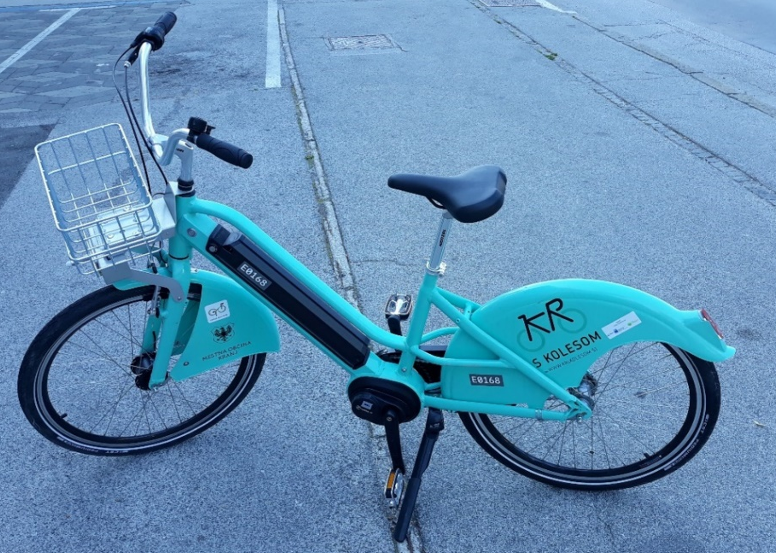
Stikalo za vklop  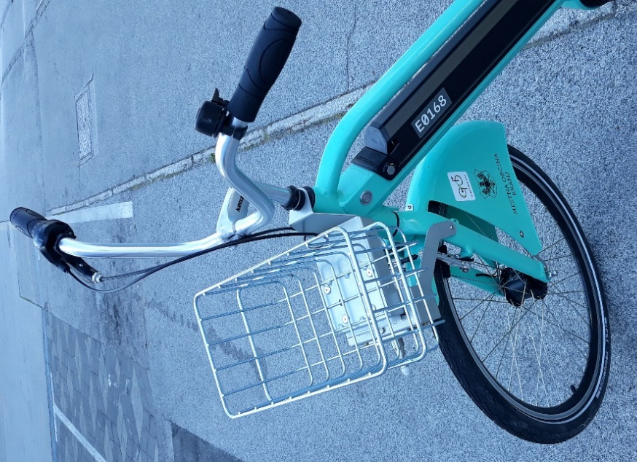 | The electric bike, v 3.0 version, is equipped with a central motor and helps you drive it. On the left side of the frame, under the handlebars, there is a switch to turn on the bike. Each e-bike has the default setting in which the motor is switched off and you have to switch it on yourself.  Starting the motor  On the left side of the frame, below the handlebars, is a switch to turn on the motor. Press and hold (1–2 seconds) to start the motor. This is when the switch (on the frame) will light up and indicate the battery status:  - Blue light – the battery is full.  - Green light – the battery is at half capacity but still full enough for several rentals and rides.  - Red light – the battery will discharge soon.
Be sure to turn on the motor before you get on the bike and do not push the pedals before that. If you accidentally start the motor while pushing the pedals, the electric motor won't assist you. Get off the bike, turn off the motor and start it again.
Press and hold again to switch off the motor. The motor also switches off automatically after the e-bike has been standing still for 1 minute or the pedals have not been pushed.

Pedal assist when riding an e-bike
With the electric motor turned on, it is activated when the pedals are being pushed in order to assist you. As you push the pedals, sensors detect their speed and the force of the pressure you exert, and the level of assistance by the motor is increased accordingly. With faster and stronger pushing of the pedals, the motor adds more power.
Here are some tips for a safe and optimal cycling with an e-bike
When you start to ride an e-bike, always make sure that you gradually accelerate your pushing of the pedals. With a full battery and a fast start of the bike, a jolt of the motor could surprise you, especially if this happens as a transition from a complete standstill, and as a result, one can lose control of the bike.
Once you have reached a normal speed, when you have complete control over the bike and there are no static obstacles, slow-moving road users, no congested traffic or situations that would require you to stop quickly, you can start cycling faster and stronger in order to reach higher speeds.
Each e-bike has also 3 mechanical gears. With these gears, you influence the pedalling and consequently change the response of the electric motor additionally. A tip for softer gear changes – stop pedalling for a moment before shifting gears.
The strength of the pedal assist also affects the range or battery life. When cycling at a higher speed, the range and life of the battery are shortened, and when cycling at a lower speed, it is greatly extended. Take this into account when riding an electric bicycle, and adjust the ride according to the terrain, conditions and your wishes regarding the duration of the ride or the final distance.
In the event that your battery runs out while riding, the bike can still be used as a regular bicycle. The rental and repayment process itself is the same as for ordinary bicycles. You can return the electric bike to any lock or station. It starts to charge automatically when locked (flashing blue light on the lock). Before leaving the station, always make sure that the bike is well locked. Do not leave bikes unattended and unlocked!
In accordance with the Road Traffic Rules Act of the Republic of Slovenia (ZPrCP), e-bikes that can be rented in the KRsKOLESOM system are adapted so that the motor is automatically activated and it assists the cyclist only if they push the pedals. The final speed is limited to 25km/h. The bike does not have a throttle lever (accelerator handle) and it starts and works only if you turn the pedals and thus drive the bike. Otherwise, a bicycle with a throttle lever would by law be considered a motorcycle.
In case of any ambiguity regarding the operation of the e-bike, you can send your questions to the contact e-mail address or call the call centre.

Version v 2.0
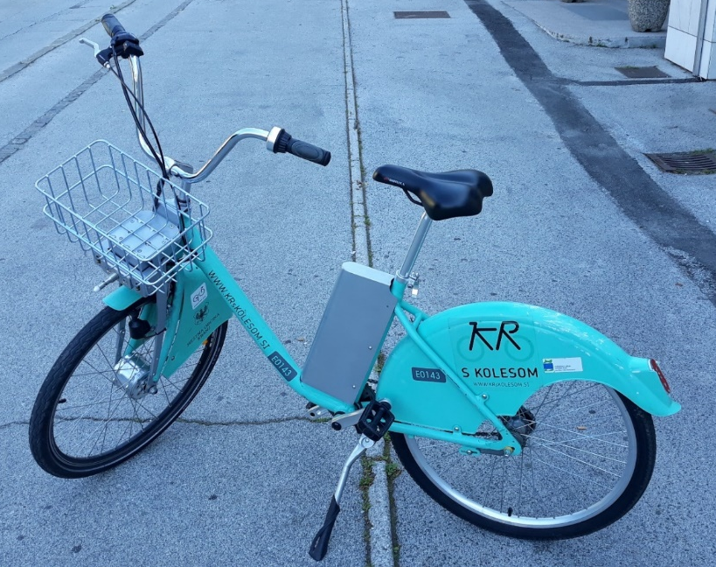
The electric bike, version v 2.0, is equipped with an electric motor at the front which assists you by providing extra power whilst you pedal. To select the assistance level and for a display of the battery status, there is a module on the right handlebar, with which you can select the assistance level (set the “speed”).
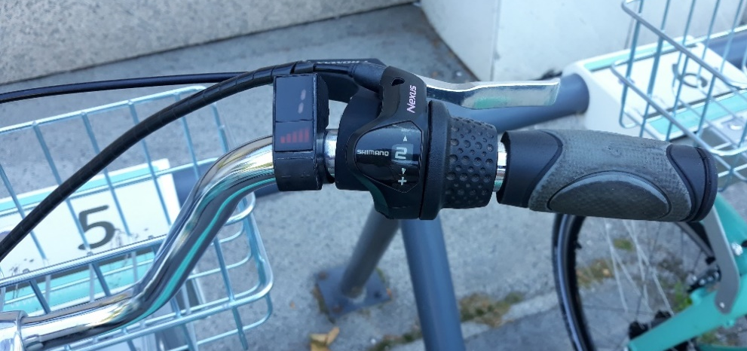
Battery status display
Setting the assistance level
On the right side of the handlebar is a module to turn on the pedal assist. Press the -/+ button to set the desired assistance level, and numbers from 1 to 5 will be displayed on the screen (1 is the minimum assistance level, 5 the maximum assistance level). If the setting on the screen shows 0, the electric motor does not assist. The motor automatically turns on and off, depending on our pedalling. When you return the bike, it is not necessary to turn off the engine and it is also not possible to turn it off. The motor stops automatically and the lights on the assistance level adjustment module turn off after a few minutes of inactivity.
When you start to cycle, always make sure that the assistance level is set to 1 or 2.
Below the engine assistance level display is a bar display of the current battery status (5 bars).
Some tips for a safe and optimal cycling with an e-bike
With a full battery and the highest assistance level (5), the jolt of the motor could surprise you, especially if this happens as a transition from a complete standstill, and as a result, one can lose control of the bike.
Once you have reached a normal speed, when you have complete control over the bike and there are no static obstacles, slow-moving road users, no congested traffic or situations that would require you to stop quickly, you can set a higher level of assistance. Setting 4 or 5 is recommended for riding on cycle paths/roads and open areas. When cycling uphill, it is necessary to shift to the lowest level of assistance – level 1 or 2. This is similar to driving a car uphill, where one always shifts to a lower gear. Driving an e-bike uphill with a higher level of assistance (3, 4 and 5) can permanently damage the electric motor.
The choice of the assistance level of the electric motor also affects the range or life of the battery. When cycling with setting 5, the range and life of the battery are greatly shortened, and when cycling at a lower speed, it is greatly extended. Take this into account when riding an electric bicycle, and adjust the ride according to the terrain, conditions and your wishes regarding the duration of the ride or the final distance.
Each e-bike has also 3 mechanical gears. With these gears, you influence the pedalling and consequently change the response of the electric motor additionally. A tip for softer gear changes – stop pedalling for a moment before shifting gears.
You can return the electric bike to any lock or station. It starts to charge automatically when locked (flashing blue light on the lock). Before leaving the station, always make sure that the bike is well locked.
Frequent acceleration and braking, are not required due to traffic conditions, can damage the motor and components in the long run and is considered to be an inappropriate use of an electric bicycle, for which a penalty can be imposed.
Before going on a ride with an electric bike, be sure to check the operation of the brakes on the bike. Even the use of an ordinary bicycle is prohibited if the brakes do not work, and if you ride an electric bicycle with non-functioning brakes, you risk causing an accident with serious injuries. Riding and the use of ordinary and electric bicycles is at your own risk. When using bicycles, people under the age of 18 have to wear a bicycle helmet, which they must obtain themselves. Others are advised to use such a helmet.
Always pay close attention to the traffic, all its participants and conditions, and adjust your cycling and speed accordingly. When riding a bicycle, you have to comply with all applicable road traffic regulations.
In accordance with the Road Traffic Rules Act of the Republic of Slovenia (ZPrCP), e-bikes that can be rented in the KRsKOLESOM system are adapted so that the motor is automatically activated and it assists the cyclist only if they push the pedals. The final speed is limited to 25km/h. The bike does not have a throttle lever (accelerator handle) and it starts and works only if you turn the pedals and thus drive the bike. Otherwise, a bicycle with a throttle lever would be considered a motorcycle by law.
If anything is unclear regarding the operation of the e-bike, you can send your questions to the contact e-mail address or phone the call centre.

Cycle responsibly!

