PUBLIC CALL TO PROMOTERS

FOR EXPRESSION OF INTEREST IN THE IMPLEMENTATION OF THE PROJECT

“THE NORTH GATE”

1 CALL TO PROMOTERS

Pursuant to Article 32 of the Public-Private Partnership Act (Official Gazette of the Republic of Slovenia No. 127/2006; hereinafter ZJZP) and other provisions of the ZJZP relating to the implementation of the preliminary procedure, the City Municipality of Kranj calls on all potential promoters to submit their expression of interest application for the implementation of the public-private project "The North Gate" in accordance with the instructions in the continuation of this call.

2 Location and description of the PROJECT

"The North Gate" is to be located about 750m from Kranj old town and about 3km from the motorway. Multi-apartment buildings make up the immediate surroundings to the east and west, and a healthcare complex is positioned to the south. The area borders onto the France Prešeren Primary School to the north and is bounded by the Bleiweisova Cesta road to the east and the Kidričeva Cesta road to the south/west.

Image 1: Project location (Source: Google Maps)

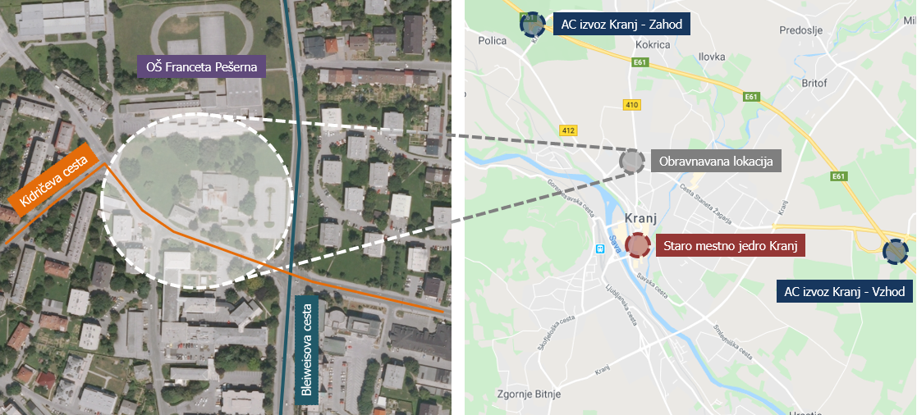

The subject of the public-private partnership is the development of the so-called “North Gate” project, which includes:

* Construction of three towers intended to facilitate healthcare and commercial services, as well as residential flats, and a private parking garage;
* Construction of a public parking garage with a temporary green roof.

Image : Presentation of the conceptual design of "The North Gate" project (Source: Explanation to OPPN, 2016)



Detailed Municipal Spatial Plans (OPPN): Bus Terminal in Kranj (Official Gazette of the Republic of Slovenia, No. 71/2016) applies in the area in question. The subject of the concrete public-private partnership does not entail the entire area as discussed by the OPPN, but only design units Ue2 and Ue3 (indicated below with a white dashed line).

Image 3: Presentation of the relevant area (Source: OPPN, Official Gazette of the Republic of Slovenia, No. 71/2016)

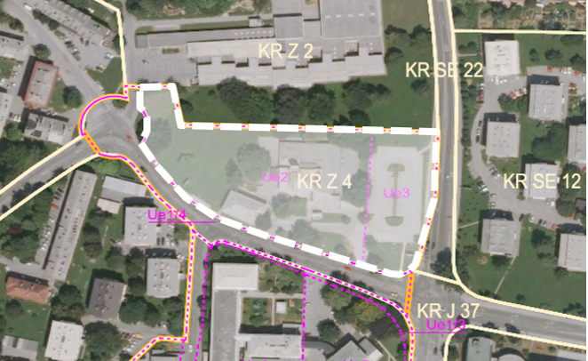

The OPPN envisages the construction of a bus terminal with an underground parking garage in the design unit 2 (Ue2) and three towers with business, healthcare, commercial and residential contents (the so-called North Gate) in the design unit 3 (Ue3). In compliance with the current OPPN, the public-private partnership envisages that the project be developed in phases: the first phase includes the construction of the North Gate building with the private and public parking garage with a temporary green roof (i.e. without a bus terminal). The second phase of the project, which involves the construction of a bus terminal, is not the subject of the planned public-private partnership.

Simultaneously with the development of the design units 2 and 3, the OPPN also envisages the construction of utility infrastructure within design unit 1/4 (reconstruction of Kidričeva Cesta road). The reconstruction of Kidričeva Cesta road will be carried out under the direction of the City Municipality of Kranj and the Republic of Slovenia and will in principle be carried out independently, but parallel with the planned public-private partnership project.

In order to have a comprehensive understanding of spatial development, it is necessary to carefully examine all the provisions of the relevant OPPN. The following contains some information from the currently valid OPPN which defines the key development options of the relevant area of Ue2 and Ue3:

* "The North Gate" building consists of 3 towers. The maximum height of the tower at the intersection of the Bleiweisova Cesta and Kidričeva Cesta roads is G+8, while the remaining two towers are limited to the height of G+6. The surface floor area of the Ue3 design unit is 3,160m² and the floor area ratio is <0.50;
* Along the Bleiweisova Cesta road, the location of the building is determined by the building line, while along Kidričeva Cesta, the ground floor is bound in by the building line, while the upper floors are restricted by the building boundary;
* A public parking garage with a minimum of 2 levels and a minimum of 170 parking spaces per level is to be built under the Ue2 unit. In the parking garage, parking spaces can also be provided for the North Gate building. The underground levels of "The North Gate" building must provide a connection to the healthcare complex (buildings in Ue5).

In line with the restrictions in the OPPN, the relevant area may be built up within the following framework dimensions:

* "The North Gate" building comprises a gross floor area of between 9,000m² and 10,000m² above ground (for healthcare, commercial, retail and residential use) and a gross floor area of between 5,900m² and 6,400m² underground (private parking garage);
* Public parking garage comprises a minimum of 340 parking spaces or a gross floor area of approximately 9,100m² underground, a temporary green roof with walking surfaces measuring approximately 8,300m²;
* The size of the relevant plot is approximately 11,420m2.

The surface areas described above for "The North Gate" project have been calculated on the basis of "OPPN: Bus Terminal in Kranj", taking into account the range between the pessimistic and optimistic possible scenarios of construction development in the relevant area. The surface area values are informative in nature and may change in the course of project development.

The public-private partnership includes plot numbers 904/11, 904/10, 904/9, 904/5, 904/2, 904/6, 904/7, 904/12, 904/14, 904/13, 904/15, 902/5 and a part of 902/4; all plots are in cadastral municipality 2100 Kranj. The area in question measures approximately 11,420m2 and has a fragmented ownership structure, as individual plots within it are owned by the City Municipality of Kranj, the Republic of Slovenia, the Kranj Parish and the owners of a multi-apartment building (building no. 363 of cadastral municipality 2100 Kranj, which is to be demolished if the project development goes forward). The ownership structure of individual properties, their surface area and intended use is shown in the table below.

Table 1 : Ownership structure of the relevant area (Source: The Surveying and Mapping Authority (GURS), the electronic Land Register (e-ZK))



____________________________________________________________________________________________

Chart content:

Katastrska občina in parcelna številka = Cadastral municipality and plot number

k.o. = cadastral municipality (c.m.)

parc. št. = plot number (p.no.)

SKUPAJ = TOTAL

Vrsta namenske rabe = Type of land use (Source: GURS)

Osrednja območja centralnih dejavnosti = Core activity surface area

Površine cest = Road surface area

Površina parcele = Plot surface area

ZK lastnik = Owner according to the Land Register

Republika Slovenija = Republic of Slovenia

MOK = City Municipality of Kranj

Splošni skupni del stavbe = Common part of the building no. 363

Župnija Kranj = Kranj Parish

Delež = Share

In principle, the public partner envisages to contribute the following as investment in the project:

* Land or building right on plots numbered 904/10, 904/9, 904/5, 904/6, 904/12 and a part of 902/4, all cadastral municipality 2100 Kranj, comprising a total surface area of about 7,104m2, owned by the City Municipality of Kranj, Slovenski Trg 1, 4000 Kranj, in a share of up to their entirety (1/1);
* Settled relations with all players necessary to establish single ownership of the relevant area of Ue2 and Ue3;
* Active participation in implementation and funding of the reconstruction of Kidričeva Cesta road and provision of adequate utility infrastructure for the relevant area, which will enable smooth project development for the private investor;
* The public partner will seek to ensure co-financing of the project from either the EU or other public sources.

With this project, the public partner pursues the following goals:

* Transfer of key risks of project implementation (construction, supervision, financing, management, etc.) to a private partner;
* Provision or development of quality healthcare and other services in this part of the city of Kranj, thus improving the lives of its residents;
* The construction of "The North Gate", which is to be a representative building at the entrance to the city centre;
* Ownership or management by the City Municipality of Kranj of the green roof and pedestrian surfaces above the public parking garage;
* Improved traffic safety in the area in question and the provision of a sufficient number of public parking spaces to meet the needs of the healthcare complex.

The subject of public-private partnership includes:

* The public partner undertakes to settle relations with all players necessary so as to establish single ownership of the relevant area of Ue2 and Ue3 and to carry out the reconstruction of Kidričeva Cesta road and build the appropriate utility infrastructure for the relevant area;
* In exchange for the public contribution, it expects the implementation of the public part of the project in the scope and content to be agreed in the public tender.

Projection of private partner's investment in the project:

* Acquisition of properties needed to integrate the design units Ue2 and Ue3 into a functional whole;
* Construction of the North Gate building with the private parking garage and outdoor adaptations and landscaping, and construction of a public parking garage with a temporary green roof and relevant outdoor adaptations and landscaping;
* Operation and marketing of the property, in accordance with the agreement in the private-public partnership tender.

3 MANNER OF PROJECT IMPLEMENTATION

A public-private partnership model has been proposed for the implementation of the project, more closely a combination of a building concession according to the DFBTO model (design, finance, build, transfer and operate) and the DFBOO model (design, finance, build, own and operate), in which the project is divided into a public part (the DFBTO model) and a private part (the DFBOO model). After the construction is completed and an authorisation to operate is obtained, a plan is adopted for the division of property units within the building, which takes into account the division of the project into public and private parts and the transfer of individual property units agreed in the concession agreement. Accordingly, the private partner becomes the owner of the private part of the project, while the public partner becomes the owner of the public part of the project. For the duration of the concession, the private partner assumes the obligation to operate the public part of the project if this is agreed by the parties. The content and scope of operation shall be agreed in the concession contract. It should be noted that in addition to the land or building rights, the public partner also contributes the project documentation at the stage to which it has been drafted, while further risks related to design (e.g. preparation of building permit documentation) lie with the private partner.

The public partner plans to transfer all key risks in the project implementation phase (construction, supervision, most of the financing, management) to the private partner, whereby the partners can also agree on the sharing of individual risks in the public-private partnership agreement.

The private partner, which will be selected through a public tender, is expected to take on risks related to design, to obtaining all necessary administrative permits, including building permit and authorisation of operation, the risks linked to construction of the facility with all associated infrastructure, landscaping, adaptations, access routes, and project financing to the extent agreed in the contract.

Of the key risks, the City Municipality of Kranj will assume the obligation to provide the necessary land for the project, except for the land which will be explicitly defined and will be the subject to agreement between the current owners and the private partner, in line with existing preliminary contracts or letters of intent. The public partner also provides the funds for the implementation of the public tender procedure to select the private partner and the cost of investment documentation. The remaining potential risks to be borne by the public partner will be defined in the public-private partnership document, with the public partner pursuing the objective of transferring as much of the risk as possible to the private partner.

Relationships will be regulated through property law institutes as the public-private partnership is established.

The public partner, e.i. the founder, will transfer to the private partner the building right for the duration of the construction and duration of the public-private partnership, the scope and duration of which will be determined in the process of selecting a private partner.

The public partner envisages the realization of the project in the framework of the institute of public-private partnership, and is willing to analyse the proposals it will receive from potential promoters regarding the model and form of public-private partnership, risk sharing, transfer of ownership and other mutual relations between future partners and to include them in the establishment of the final form and model of the public-private partnership within the limits of public interest, which the public partner is bound to protect. Promoters are therefore encouraged to present, without restrictions, their ideas for public-private partnership models and forms which they consider to be financially, economically, technically and legally optimal.

EXISTING DOCUMENTATION

The public partner has the following project documentation:

* OPPN: Bus Terminal in Kranj (Official Gazette of the Republic of Slovenia, No. 71/2016)
* Traffic study and conceptual design of Kidričeva Cesta road, project no. PR460-CE-IDR, Kranj, October 2019, designed by Provia d.o.o.

Potential promoters can obtain the documentation by sending a request to the following e-mail address: [Tanja.Hrovat@kranj.si](mailto:Tanja.Hrovat@kranj.si)

The documentation that promoters will receive by e-mail is confidential in nature and may only be used for the purpose of expression of interest application. The values provided are estimations, therefore the public partner recommends that the promoters draw up their own analyses.

4 PREPARATION OF THE EXPRESSION OF INTEREST APPLICATION

MEETING WITH POTENTIAL PROMOTERS

At the request of a potential promoter and before the application deadline, the public partner will organize a meeting and visit to the site with each promoter separately, giving promoters the opportunity to obtain detailed information about the project.

Interested promoters may send a request for a meeting and viewing to the following e-mail address: Tanja.Hrovat@kranj.si Attendance at such a meeting is not a condition for submitting an expression of interest application.

APPLICATION DEADLINE

The public partner expects expression of interest applications for the public-private partnerships until the end of day of 26 October 2020 at the address: Mestna občina Kranj, Slovenski trg 1, 4000 Kranj. The envelope should state: Expression of interest application for the implementation of the public-private partnership project "The North Gate" - DO NOT OPEN!

APPLICATION CONTENT

There are no prescribed forms for application submission. The expression of interest application should be drawn up on the promoter's own documents. The application should contain the following documents:

* Presentation of the promoter, including an analysis of the development possibilities and capabilities of the promoter;
* The name of a contact person with contact details (telephone, e-mail);
* A description of the project and conceptual solutions as envisaged by the promoter and within the scope of investment that the private partner is willing to undertake;
* Implementation timeline;
* Economic assessment of the project implementation;
* Presentation of the estimated value of the investment and the envisaged financial construction, indicating the risks that an interested person would assume by estimating the value of individual risk assumed;
* A scan of the entire application in electronic form;
* An estimation of revenue and cost in the lifespan of the project.

The public partner will also consider applications to which not all of the above documents will be attached, provided that it will be possible to identify from the application an interest in implementing the public-private partnership.

Promoters may also submit proposals to change the concept of the project and other documents, not required by this call.

BUSINESS SECRET

The public partner will protect confidential information and business secrets duly marked as such in the expression of interest application. Data that cannot be classified as a business secret by law will not be protected.

The public partner reserves the right to use all information that will not be marked as a business secret by the promoter in drawing up the final content, model and scope of the tender documentation for the selection of the private partner.

The promoter who submits an expression of interest application for the public-private partnership will have the same rights as other candidates in a possible public tender procedure. The submission of the expression of interest application does not make the applicant a candidate in the further process of selecting the contractor of the public-private partnership. The costs of preparing and submitting the application are borne entirely by the promoter.

This public invitation to promoters is a non-binding document that merely describes the intention of the public partner. The public partner reserves the right to change the content, scope and parts of the project described in this call. The final form of the public-private partnership model, the scope and content of the project and the obligations of the partners will be defined in the public tender procedure for the selection of a private partner.

ADDITIONAL INFORMATION

Promoters can obtain any additional information by sending a request to Mrs. Tanja Hrovat via email: Tanja.Hrovat@kranj.si

Matjaž Rakovec,

Mayor of the City Municipality of Kranj

# **ENVELOPE**

|  |  |
| --- | --- |
| SENDER (PROMOTER): | RECIPIENT (PUBLIC PARTNER): |
|  | **MESTNA OBČINA KRANJ**  **SLOVENSKI TRG 1**  **4000 KRANJ** |
| Expression of interest application for the implementation of the public-private partnership project  “The North Gate” | |
| DO NOT OPEN! | |
| DATE AND TIME OF RECEIPT OF APPLICATION:  (To be filled in by the public partner’s mail room) |  |